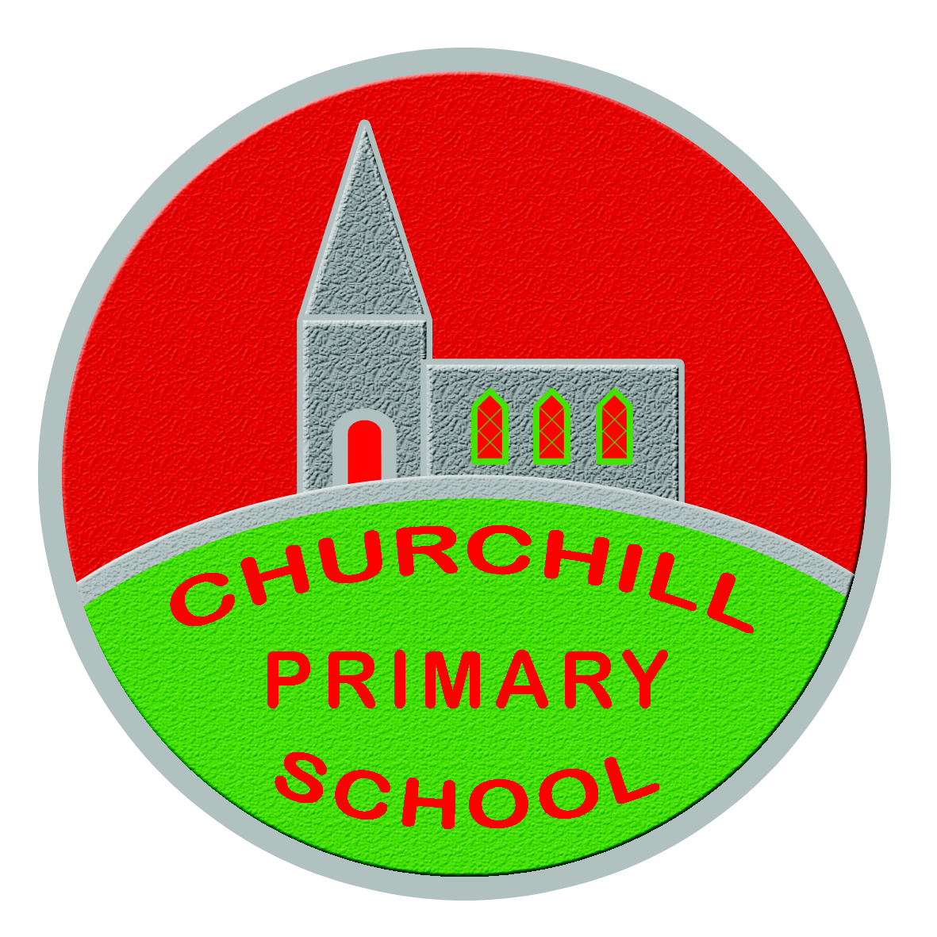
Churchill Primary School Holiday List -
2023/2024 (Inclusive Dates)

School term runs from 30th August 2023 to 28th June 2024.
30th and 31st August 2023 are half days until 12pm – there will be no EA transport on these days.
Friday 1st September will be a full day as normal with meals and transport.

Holidays:
Half term (term 1) 30th, 31st Oct, 1st, 2nd, 3rd Nov
Christmas 22nd Dec – 4th Jan 2024 (inclusive)
Half term (term 2) 12th-16th Feb 2024 (inclusive)
18th March 2024
Easter 26th March – 5th April 2024 (inclusive)
Bank Holidays Mon 6th May & Fri 24th & 27st May 2024

Early Closures (11am):
Finish for Christmas: Thur 21st Dec
Finish for Easter: Mon 25th March
Finish for summer: Fri 28th June

*This list is subject to change*

